Title

by
[Author Name]
[Author Qualifications]
A thesis submitted to the [University]
to fulfil the requirements for the degree of
[Degree]
in the discipline of
[Discipline]
[Location], [Year]

Author’s Declaration
I declare that this thesis is my own account of my research and contains as its main content work which has not previously been submitted for a degree at any tertiary education institution.

[Author]

The blue text has been modified from Henryon & Miller ‘Writing a Thesis’ (unpublished)

Abstract
Write your abstract last. It should be brief (aim for <300 words). If you have written your thesis well, your abstract ‘writes itself’. A structure is as follows:
- A few sentences that describe your background, i.e. why did you do the study you did. State your hypothesis
- A few sentences that describe how you did your study? Your experimental design
- A few sentences that describe what you found - your main result(s). (Include: direction and magnitude of responses, and P-values IF significant)
- A few sentences that describe your Conclusions – your main conclusions; was your hypothesis supported?
NB: (and keep it brief but concise: Remember it’s an abstract – the details are in your paper)

Acknowledgements
[Body Text]

Table of Contents
Chapter 1 General Introduction 17
1.1 Heading Level 2 17
1.1.1 Heading Level 3 18
1.1.1.1 Heading Level 4 18
Chapter 2 Literature review 19
Chapter 3 General methods 21
3.1 Your study species 21
3.2 Your study sites 21
3.3 General methods or statistical approaches 21
Chapter 4 Experimental study 1 22
4.1 Introduction 22
4.2 Materials & methods 23
4.3 Results 23
4.4 Discussion 23
Chapter 5 Experimental study 2 etc… 25
5.1 Writing style 25
5.2 What is a paragraph? 25
5.3 Let’s think about some punctuation 25
Chapter 6 Thesis by publication? 27
6.1 What format should your thesis take? 27
Chapter 7 General discussion 31
Chapter 8 Do you need more help? 32
8.1.1 Where can you get help with preparing your thesis? 32
8.1.2 How long will your thesis take to complete? 32
8.1.3 What to do when you get near completion of your degree? 33
8.1.4 Printing and printing costs 33
8.1.5 How long will examination take? 34
8.1.6 What format should the references be in? 39
Appendix A Give each appendix an informative title 41
A.1 [Sample Heading 8] 41
A.1.1 [Sample Heading 9] 41
Appendix B Give each appendix an informative title 43

List of Figures
Figure 1.1. [Sample figure legend]. Note that figure legends should go BELOW the figure. To stop the figure and its legend being separated over two pages, highlight the image and then go to Menu> Paragraph > Lines and page breaks and tick both ‘keep lines together’ and ‘keep with next’)] 2
Figure 1.2. [Sample figure legend] 2

Figure App A.1 [Sample Appendix Figure with Caption (below)] 3
Figure App A.2. [Sample Appendix Figure with Caption (below)] 3

List of Tables
Table 1.1. [Table headings] go ABOVE the table they are referring to. You will note that we suggest a different looking font for the tables and the figures – it makes them stand out from the text of the rest of the document. 2
Table App A.1. [Sample Plain Table with Caption Above] 22
Table App A.2. [Sample Appendix List Table with Caption Above] 22

List of Abbreviations
[Body Text]

General Introduction

Heading Level 2
Your first chapter should be your general introduction. Present your thesis aims, introduce the outline of your thesis chapters.
The purpose of this section is to provide a brief background (relevance) for the material to follow, plus to set up a unifying hypothesis. This is different from the usual hypothesis in that it is less specific, but provides a reasoned argument why the experiment(s) contained in the thesis was carried out. To do this, the General Introduction is constructed from a logical sequence of facts that make the hypothesis a sensible thing to test.
Example:
- In general, ewes mate every sixteen to seventeen days during the breeding season until they become pregnant. After they become pregnant they no longer mate and this can be a good way of identifying which sheep are pregnant at the end of the mating period.
- In a tropical environment, many ewes that appeared pregnant by the above criterion did not have a lamb.
- The temperatures during the mating season were always extremely high.
- High temperatures are known to affect the survival of embryos in other species.
Unifying hypothesis: The failure of apparent pregnancies in sheep in this environment is due to the high temperatures around mating time.
To test this unifying hypothesis you would need to do a number of experiments, each with its own specific hypothesis.
An hypothesis one of the most important statements in your thesis. Get your hypothesis sorted, and your thesis will fall into place (i.e. it tells you what needs to go in […or more importantly what doesn’t need to go in…] to your ‘Introduction’, ‘Materials and Methods’, ‘Results’, and ‘Discussion’ sections).
Note: The outcomes of the tests of the specific hypotheses may sometimes result in the conclusion of rejecting the unifying hypothesis, and to suggest a completely new hypothesis based on the results. This should make no difference to the unity of the thesis or to the ease with which you are able to write it.
The General Introduction should help the reader understand the main theme of the dissertation, and thereby help give relevance to the contents of the Literature Review.

Heading Level 3
All your headings are available to you under ‘Styles’. If you can’t see them all, then click the small box on the bottom right hand corner of the Styles menu and it should bring up a list of the styles you have in your document.
This numbering layout is required for theses.

Heading Level 4
Sample footnote. Footnotes will appear at the bottom of the page. Note that in scientific journals today, there is a move away from footnotes – many journals will not accept footnotes. Consider whether the text could be included in the text of your page, your glossary page, or whether it is needed at all.
Sample cross reference (Figure 1.2). Remember to list all your tables and figures in your text. Also make sure that they order in which they are presented in the text follows the order in which you present them (i.e. don’t have Fig. 1.2 before Fig. 1.1). Note that Figures and Tables need to be capitalised because they are proper names.
Sample: Body Text Indent. This can be used for direct quotes – remember direct quotes need to have ‘double inverted commas around them’ and the reference needs the page number that you took the quote from (Author 2015, p21)
[Sample: Quote] or you could also change the text colour...
- [Sample: Quote NL] Integer consequat hendrerit felis et sodales. Cras ac tortor nulla.
- [Sample: Quote NL] Proin et odio vel dui ullamcorper feugiat in quis velit.
- [Sample: Quote NL] Praesent ultrices, risus nec cursus pellentesque,.
- [Sample: Body Text BL] Bulleted text is a good way of laying out your text in a neat readable manner.
- [Sample: Body Text BL]
- [Sample: Body Text BL]
- [Sample: Body Text NL] Numbered lists are also very powerful.
- [Sample: Body Text NL]
When you present tables, don’t be tempted to colour in the cells. It can become very messy and does not look professional. When in doubt, look at some journal articles for some ideas for formatting (look up their ‘Instructions for Authors’). You will see that journal articles have very simple formatting requirements. They usually do not let you use vertical lines in tables, and only minimal horizontal lines – as per the following:
Table 1.1. Table headings go ABOVE the table they are referring to. You will note that we suggest a different looking font for the tables and the figures – it makes them stand out from the text of the rest of the document.
Table headings need to be kept on the same page as the table itself and (all the lines of the table). To do this, this template style has been formatted: Menu> Paragraph > Lines and page breaks and tick both ‘keep lines together’ and ‘keep with next’.
[Sample Plain Table] | Top Row | Top Row
[Sample Table Text] | [Sample Table Text] | - [Sample bulleted]
[Sample Table Text] | [Sample Table Text] | - [Sample numbered]
[Sample Table Text | [Sample Table Text] | [Sample Table Text]
[Sample Table Text] | [Sample Table Text] | [Sample Table Text]

[Sample: Body Text with cross reference] Lorem ipsum dolor sit amet, dolor sit amet consectetur ([Sample cross reference] see Figure 1.1).
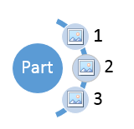
Figure 1.1. [Sample figure legend]. Note that figure legends should go BELOW the figure. To stop the figure and its legend being separated over two pages, highlight the image and then go to Menu> Paragraph > Lines and page breaks and tick both ‘keep lines together’ and ‘keep with next’)]

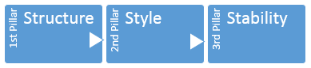
Figure 1.2. [Sample figure legend]
[Sample Caption Below Supp]

Literature review
The literature review is where you put most of your background reading/review. Make sure that you cover the background that is relevant to your study.
Identify the ‘problem’, or the gaps in our knowledge. You want your reader to come to the point after reading this where they are convinced that the study and approach that you did is exactly what they think is needed to fill in the gaps in the literature.
The Literature Review is meant to act as a base for the experimental section of the thesis. It is essential that all of the literature leading to the development of the specific hypotheses for each experiment should be covered.
The Literature Review should take the reader almost, but not quite, to the point where the specific hypotheses are presented. In this way the formal introductions to each of the experiments later on can be developed in the minimum of space.
Deciding how much to cover in a review is sometimes difficult. A successful strategy is to assemble all of the material that will lead to the development of each hypothesis to be tested later in the thesis. Sometimes this material overlaps and the material for several hypotheses can be amalgamated into one section. When this is done you may find that there are distinct gaps between sections. New material may have to be introduced to unite all of the sections into a coherent structure.
Example:
Let's assume there are five environmental factors that predispose a crop to attack by insects and your hypothesis presents a detailed study of two of them. It is highly likely that a worthwhile Literature Review would have to discuss the other three factors at least to some degree in order to achieve balance. What is important is that all of the material introduced into the Literature Review has a purpose; either to develop arguments for use in the experiments to be described later on, or to unify these arguments.
A literature review is not simply a description, paragraph-by-paragraph of individual studies. It is a synthesis of ideas, derived from your reading of these studies, that lead you to make specific statements. Do not rely on your reader to put these together. If Smith (1988) found xxx. Jones (1990) found xxx also. Then make the statement of observation that under these specific conditions, xxx is generally observed (Smith 1988; Jones 1990). Or if they found different things, then describe that while Smith (1988) found xxx, Jones (1990) recorded a different outcome, with yyy.

General methods
It is a good idea to have a general methods chapter where you cover:

Your study species

Your study sites

General methods or statistical approaches
that you used across all studies that you do not want to have to repeat for each experimental chapter.
A thesis often describes a number of experiments but these generally have several features in common. They have been carried out in the same region or on the same type of soil; they may have used the same breed of animals, the same chemical analyses, and so on. To present each experiment with a complete description of the materials and methods used each time would be boring, distracting and a waste of paper. Instead it is common to include a chapter that gathers together the techniques used in most of the experiments. This chapter may also include validation of methods used, even if in some cases they may involve small test experiments.
The purpose of the Materials and Methods sections (general and specific) is to provide information to the reader which allowed you to test your hypothesis, e.g. the experimental design must test your hypothesis, the subjects and techniques you used must be those appropriate to your hypothesis.
How much information is enough? A good rule is enough information that allows anyone (who had nothing to do with your experiment) to repeat your experiment. Though you can assume the person has a moderate scientific knowledge, so for example, explaining which size measuring-cylinder should be used is not necessary.
How much is too much? If techniques are standard procedures or have been documented previously in refereed literature, then it is acceptable to refer the reader to the information in these other papers. Otherwise, all scientific papers would be massive. However, it is essential to describe any of your deviations or additions to published procedures.
Remember also to describe the statistical methods you will use to analyse the data you collect.

Experimental study 1
Each of your experimental data chapters can be presented in the form of a manuscript, with sections for ‘Introduction’, ‘Materials and Methods’, ‘Results’, and ‘Discussion’.
this is how I start writing a paper – it may help you.
- Write out your key research questions (as hypotheses or questions – whichever suits you). Make some central predictions about the patterns of responses you predict would happen

- Analyse your data according to the central hypotheses you are testing. Tablulate the results of analyses. Draw up graphs of key results. Spend time on these – think about what you really want to present and make sure that the story is clearly told through these. Write figure legends and table headings that describe what is going on in each. Use these to identify 3-5 key points that you want to make in your paper.

- Describe the methods that you needed to do to get to the results you describe. Identify how you collected your specimens, the measurements you made, and then how you analysed the data to address your key questions. Wherever you present an analysis in your results, make sure that you explain, in detail, how you did the analysis. You need to provide enough data that someone could replicate your analysis. No one has ever been criticised for providing too much detail for their approach to analyses, but plenty have been for not providing enough.

- We assume that you have arrived at your central hypotheses through review of the current literature and identifying the gaps that exist. Therefore in your introduction, present these in such a format that your reader would follow and come to the same conclusion that the work needs to be undertaken using the same approach.

- The first paragraph of the discussion should summarise your key findings (don’t introduce literature in this paragraph – keep it about your work). Then write your discussion around your central 3-5 findings, comparing and contrasting with the published literature.

- Write your conclusions next.

- Last of all your abstract – summarise your study with 1-2 sentences of background, methods, results, and conclusions.
The ‘Lolly Model’ for overall structure:
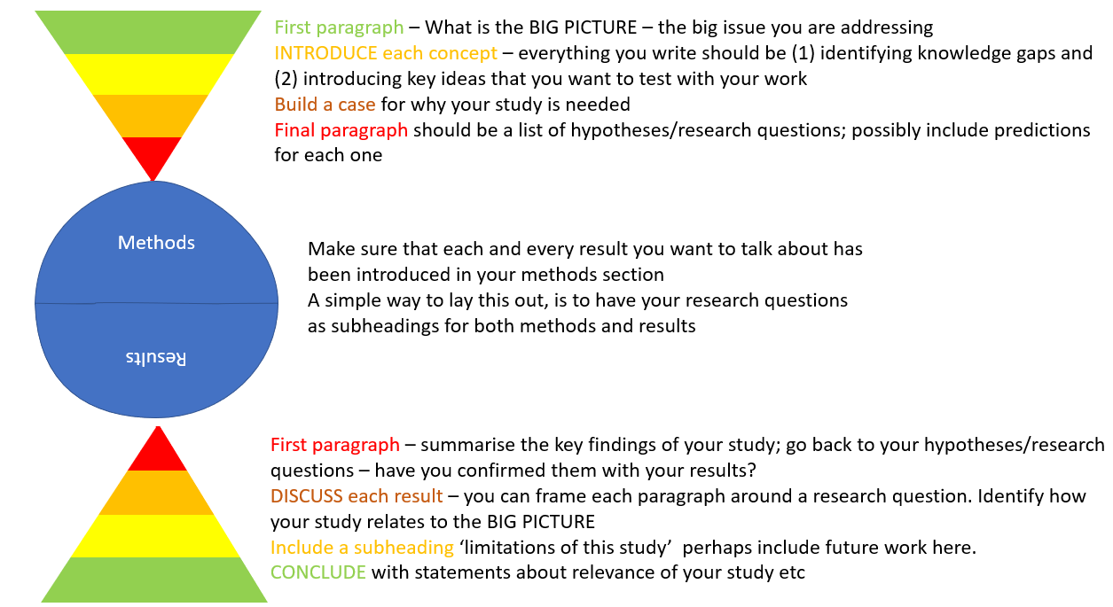

Introduction
Covering the background literature specific to this study.
The ‘Introduction’ is usually fairly short because a great deal of the background has been given in the ‘General Intro’ and ‘Review’. It is sufficient to extend the arguments already made in the ‘General Intro’ and ‘Review’ and complete them with a specific hypothesis for the experiment.
A specific hypothesis is a TESTABLE statement. ‘Testable’ means exactly that, can the hypothesis be tested or is it just an ambiguous statement? Statements such as ‘…..the hypothesis was to study the effect of chemical X on plant Y…..’ or ‘…..to investigate if altering chemical X has any effect on plant Y’ are NOT testable. On the other hand, ‘The hypothesis was that increasing the application rate of chemical X would decrease the root growth of plant Y’ is testable.
Some people say that their experiment didn’t have an ‘Hypothesis’, it just had an ‘Aim’. This suggests that they didn’t have enough background information to form a hypothesis, and therefore questions should be asked as to whether they were justified in carrying out the experiment in the first place. However, in most cases the answer lies in the fact that they hadn’t delved deep enough into the background information, or been too lazy to do so, to try and form an hypothesis.
To put forward your hypothesis, you first have to present a logical series of arguments that lead up to it, and that make it a sensible hypothesis to be tested. An introduction usually consists of two or three paragraphs (generally, any more is just waffle!!).
- Final paragraph: Contains your hypothesis, it is also good practice to briefly indicate the basic design of the experiment you conducted to test the hypothesis. For example, your last paragraph in your introduction might go something like: ‘In this study, weaned pigs were housed in group-pens of different areas. The hypothesis that was tested was that increasing the pen area size would decrease the incidence of tail-biting.’
- First paragraph (or two): The information that goes here is determined by your hypothesis. You need to provide a series of logical pieces of background information that gently eases the reader to the point where it appears very sensible to put forward your hypothesis. After reading the introductory paragraphs, the reader should have a good idea of what your hypothesis will be before actually reading it in the final paragraph.
- Statements of fact, e.g. ‘…it has been shown previously that aggressive behaviour in pigs is associated with competition for food or bedding..’, need to be justified by citing the source of the information (i.e. a previous study published in a refereed journal or book). Otherwise, the reader can’t decide whether your arguments are scientifically proven facts or your own personal (untested) beliefs. There are a number of different ways of citing references within the text, and if you are going to submit a paper to a journal you will have to check their specific format for details, however here are a few common methods:

Materials & methods
Covering the methods specific to this study.
Most of the material to be covered in this section should already have been covered in the general Materials and Methods section. Only specific information, unique to the experiment, need be given.

Results
I usually start writing my results first.
The results are given in full. However, students sometimes present results far more expansively than they should. Rather than cluttering the main ‘Results’ section with results not directly related to the hypothesis, it is often prudent to observe the following guidelines, or to compile interesting but ‘non-essential’ results in tabulated form in appendices.
- MOST IMPORTANT RESULTS COME FIRST. The importance of your results is determined by your hypothesis. Results that directly support/reject your hypothesis are the most important.
- Start each paragraph (or sub-section) of your Results section with an ‘overall effect’ sentence. Essentially, you are starting a section by stating if a particular effect was important, if a trend was evident, etc. etc. Then you can go into further specific details about the effect.
- In the specific details, it is important to let the reader know the direction of any significant response (e.g. increase, decrease, more, less, etc.), the magnitude of the response (e.g. 2 fold, 100 times, 10%, double, etc.) and the level of statistical significance (e.g. P < 0.05, P<0.01, P<0.005, etc.). There is no need to describe the direction, magnitude or p-value of a non-significant comparison, i.e. just state that ‘..there was no effect..’. There is also no need to describe ANOVA table results, etc. in the ‘Results’ section. If you think these are important you can put them in an appendix and refer the reader to the appropriate one.
- Your text and figures/tables should complement each other, but be self-explanatory on their own. Within the text, you simply refer the reader to the figure or table in the following way: ‘…X was twice as big as Y (Figure 1)’. Statements such as: ‘The effect of pen area on aggressive behaviour is summarised in Table 2’ is a ‘nothing statement’, i.e. it does not say anything about the data, and puts the onus on the reader to do all the work of deciphering Table 2! (….make it easy for the reader !!!!!).
Text and tables/figures complimenting each other, but being self-explanatory, also means that the figure or table must be able to stand on its own. That is, you should be able to look at the tables or figures and be aware of the following: treatments, subject type, group size, variables measured, units of measurement, time course, significant effects, major trends, etc., (i.e. it must have fully descriptive title, legend, axis descriptors, units, footnotes, etc….

Discussion
This section deals with the results in relation to the specific hypothesis for that chapter.
- FIRST, and the only thing that will ever be first, is to state what your most important finding was, i.e. if your hypothesis was supported or not? Make it obvious! For example, ‘The hypothesis that increasing the area of X decreases the amount of Y was supported, was not supported, or was partially supported.’ Then highlight the specific effects, the trends, etc. which lead you to support, not to support, or partially support your hypothesis (…briefly without repeating your Results section). Suddenly, you have now written the two most important paragraphs of your paper; the last paragraph of your ‘Introduction’ and first paragraph in your ‘Discussion’.
- How do/does the results/information from the literature compare to your results. Note, this is your paper about your results so you are comparing other researchers findings to your results (e.g. ‘Jones (1977) and Jensen (1989) also found that…..’). You do not simply back up their findings (e.g. ‘My results are similar to those reported by Jones (1977) and Jensen (1989)’).
- Why did you get the results you did? What are the biological, physiological, physical, experimental error, etc. reasons or possible reasons that explain the results you got? Use support from the literature where necessary.
The most important arguments (in relation to your hypothesis) come first and are generally the longest paragraphs. In (a), it was mentioned that firstly you state your most important finding (in relation to your hypothesis). Later, you can (if necessary) discuss other less relevant or unusual results (…and don’t feel obligated to describe every measurement you took). You do this in the same way as indicated in (a), (b), and (c). But remember, give less emphasis to these ‘less important’ results – as they are usually not directly related to your hypothesis.

Experimental study 2 etc…

Writing style
Let’s talk about some things you should to tighten your writing style:
Do avoid saying: There was seen to be more effort put into discussions than … I sometimes think that you could do a search-replace for key terms – they can appear so often.
I have a personal thing against ‘was done’. There are more elegant ways to say that an experiment was ‘carried out’ was ‘undertaken’ etc.
The word ‘the’ can be over used – go though your text and check whether a sentence has better meaning if you remove the word.
Don’t tell us that the stats indicated x, y, z – it is a boring way to present your results. Tell us what the story was (and then you can indicate which stats test supported this conclusion – sometimes putting the stats in brackets after the statement helps).
Don’t open your results by indicating what the tables and figures show us (an astute reader can see for themselves). Tell us the story and then indicate where this is illustrated (Figure 1).

What is a paragraph?
A paragraph has 3 parts: 1. an opening sentence (tell us the point of the paragraph), 2. The supporting material (e.g. cross referencing your data with that in the literature) and 3. A sentence that leads on to the next paragraph.
One sentence cannot make up a paragraph (the only exceptions I would allow would be in results, where you need to separate presenting different types of data).
A paragraph that goes on for 1.5 pages has lost the point. Think about readers (like me) with short attention spans.

Let’s think about some punctuation
If you are going to present a list of items for example:
- this one
- that one
- the other
Then it was a colon you needed, not a semicolon.
The 'Oxford comma' is an optional comma before the word 'and' at the end of a list: We sell books, videos, and magazines. It's known as the Oxford comma because it was traditionally used by printers, readers, and editors at Oxford University Press. Some use it only where necessary to avoid ambiguity.
Do you need a hyphen (-) or a dash (–)? Hyphens connect text where the words should be linked e.g. value-added or easy-to-read format. A dash separates text in a sentence – for example here. It can also be used – as here – in pairs.

Thesis by publication?
There is a growing movement across the world towards theses by publication. Too often theses are left on the shelves of libraries and the work is not appreciated (or is repeated because other people were not aware of previous studies). Think about the statement that ‘It is not Science until it is published’, because science is about the steady increase in knowledge – building on previous work to advance our understanding.
Theses by publication should not be any more daunting than the ‘traditional’ format for a thesis. You need to write succinctly and professionally for either format. Not all chapters have to be published (or publishable – we acknowledge where there are some studies that did not succeed in their aims due to low sample size, inappropriate methods etc).

What format should your thesis take?
Guidelines for thesis formatting can be found on the Graduate Research Office website: http://our.murdoch.edu.au/Research-and-Development/Resources-for-students/Thesis/Style-format-and-binding-of-thesis/
As mentioned in the guidelines:
- Research formats vary greatly between academic disciplines, therefore it is impossible to prescribe a standard form of thesis that would suit all disciplines.
- Schools have different conventions for the presentation of a thesis and papers in professional and scholarly journals, and these should, in general, be followed, unless there are compelling reasons for doing otherwise.
- ‘TRADITIONAL’ In VLS, most theses take the form of a general introduction, general methods, a number of experimental chapters, and an overview of the project/general discussion.
- ‘BY PUBLICATION’ An increasing number of students are electing to submit their thesis as a compilation of a number of journal articles. These should be in the format for submission to nominated journals, but they do NOT all have to have been accepted prior to submission. The thesis should also include:
  - A general introduction clearly outlining the theme of the thesis, as well as the aims and objectives of the various chapters, and how they will fit together.
  - You may choose to include a general methods chapter.
  - A final general discussion and concluding chapter integrating the results from the various chapters, emphasising elements that emerge from these, identifying gaps in the research area that are now apparent, interpreting the implications of the results, and highlighting future direction for research. This chapter should NOT duplicate material that is already contained in the discussion sections of the individual chapters/papers.
Your supervisor should be continuously encouraging you to publish your work for a number of reasons:
- Publications are very important if your wish to pursue a career in science.
- Writing your thesis as a set of papers will expose you to the discipline of writing research papers, a skill which will continue to be useful in your career (whether it be scientific or otherwise, writing cogently and succinctly is a valuable skill).
- Publishing is a very valuable reward which will inspire you to complete the rest of your thesis.
- ‘It is not completed unless it is published’. Too much data is bound in theses in libraries where no one will ever read it. This is an unethical use of animals, resources and your (and your supervisor’s) time.
You will need to discuss your thesis format with your supervisors. The following guidelines (relevant to science) are available for thesis format from the Research Graduate Office (http://www.research.murdoch.edu.au/gradcentre/formatthesis.html).
A thesis:
- may consist partly of published work;
- may consist predominantly of published work, provided that the thesis also includes material that provides coherence to the thesis as an integrated work ;
- may describe work done in conjunction with the supervisor or other persons, provided that the candidate's personal share in the investigation is clearly stated, and that this statement is certified by the supervisor;
- must be written in clear and concise language and in English (unless the Director of Postgraduate Studies has given approval for it to be in another language);
- must conform to scholarly standards of presentation, citation and referencing for the discipline;
- must include an abstract of approximately 300 words;
- must include a declaration by the candidate that it is her or his own account of the research, the extent to which the work of others has been used, and (except for a resubmitted thesis) contains as its main content work which has not previously been submitted for a degree at any University;
- must not exceed 100,000 words, excluding maps, diagrams and bibliography, unless otherwise approved by the Director of Postgraduate Studies on the recommendation of the supervisor;
- must be in double-spaced typescript.

General discussion
The last chapter of your thesis should include a synthesis of all the other work presented. Make sure that your conclusions are clear. Also, it is an important demonstration that you can think beyond your data to identify potential future work – you can ‘fly some kites’ – think about how you would like to have done things or would do things (if you had more time and money!).
At this point we return to the unifying hypothesis and commence the discussion based on all of the results and their support or rejection of the hypothesis. Until now each experiment should have been discussed separately. A complete integrating discussion in this separate section can be logically arranged much more easily than asking the reader to refer back and forth between individual experimental sections.
In the General Discussion, results can also be discussed in relation to a less specific unifying hypothesis, and therefore wider interpretations, relevance and implications can be covered. For example, you could indicate how the pool of scientific knowledge in the area covered by your thesis has been changed because of your results.
Whether or not you choose to write a 'Conclusion' segment at the end at the end of the General Discussion is a matter of personal preference. Some people think that at the end of a long thesis some condensed wisdom is desirable to highlight the main points of the thesis. Others feel that this is adequately covered in a good thesis abstract.

Do you need more help?

Where can you get help with preparing your thesis?
The Murdoch University Research Graduate Office runs some courses on writing a thesis which may be of use (e.g. through the GREAT program: ‘Academic and Writing Skills’ workshops).
The Teaching & Learning Centre (Student Learning) also may be of some assistance: (http://www.research.murdoch.edu.au/gradcentre/teachlearn.html). The staff cater for both native speakers of English and students for whom English is a second language. They provide some workshops, individual consultation and have some capacity to assist with thesis editing.
Please note that although these services may assist with getting you over writer’s block (numeracy, time and stress management, note-making and critical thinking, etc.), they will only help you improve your writing, not to ‘correct’ it for you, and you will still need to work closely with your supervisors in terms of the content of your thesis.

How long will your thesis take to complete?
Writing a thesis will take MUCH longer than you think it will! Do not underestimate how hard it is to finish a study and write it up to completion. The last 80 PhD theses completed through this School have taken an average of 5±2 years, but the minimum was still 3 years and the maximum has been 12 years! So stick with it – other people have had a hard time finishing too and very few people have an easy and quick PhD.
Expect that your supervisor will take a number of weeks to get each draft back to you, and so to run through a number of iterations of a chapter can take months!
Speak with your supervisors about how you can stage the writing up. For example, the following suggestions may help:
- Write up your LITERATURE REVIEW (to a high quality standard) as a part of your program of study.
- It is a good idea to write up (to a high quality standard) your METHODS as you carry out your experiments.
- When you finish a set of experiments, analyse and write up (to a high quality standard) your RESULTS as you go – do not underestimate how much (especially methods and results) you will forget!

What to do when you get near completion of your degree?
FINDING EXAMINERS. Theoretically, students are not supposed to know who their examiners are until after the process, and are not necessarily involved in the decision making process either. When you are nearing completion, however, it is a good idea to prompt your supervisor into thinking about and approaching potential examiners. You will need to have a FINAL TITLE and an ABSTRACT (brief abstract of approximately 300 words) to send to the potential examiners, and you and your supervisors both have to agree on a reasonable submission date.
Don’t leave this process too late – potential examiners may take three or so months to approach and get their commitment to mark your thesis.
Your final title and abstract will also be needed to accompany your Notice of Thesis Title & Abstract form which is needed about two months before you submit your thesis.

Printing and printing costs
You will be able to get your thesis printed out and bound by the campus printers (Murdoch Print). They will accept a grant number to cover the costs of printing.
If you do not have any maintenance funding left, you may be eligible for other support. PhD students who have received a scholarship from Murdoch (APA or MURS, MIPS, IPRA) are eligible for $840 (PhD) or $420 (MPhil) to print out their thesis. If you have had an external scholarship (e.g. partnership, government or industry supported scholarships; RMTs also come under this category), then you will need to check with your scholarship conditions to find out if this funding is available. Ask your supervisor for details.

How long will examination take?
As a general guide, a PhD thesis will take about 6-9 months to pass through the examination process. The following flow diagram (http://www.research.murdoch.edu.au/gradcentre/examguide.html) demonstrates the steps taken in examination of your thesis. There are many steps, and therefore this can be a lengthy process (also, the Research & Degrees board sit only about every 6 weeks to sign off on these steps).

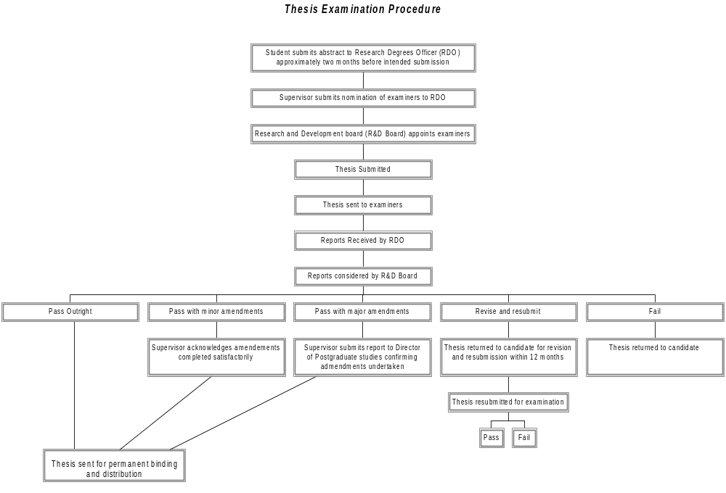

References
Pick a formatting style and stick with it. It is a good idea to get hold of a referencing programme early in your degree and start using it from Day 1. e.g. Endnote is available to download from the Murdoch University library for FREE for staff and students: https://webapps2.murdoch.edu.au/download-manager/.
Put all the references used over your whole thesis at the end of the thesis – do not have separate reference sections for each chapter/study (it will avoid repetition).

What format should the references be in?
We do not directly provide guidelines for referencing formats, however the following Library links provide some advice: http://library.murdoch.edu.au/Getting-help/Referencing/
Endnote is the preferred referencing tool: http://libguides.murdoch.edu.au/Endnote
- References concerning unpublished data and ‘personal communications’ should not be cited in the reference list but may be mentioned in the text, e.g. (Adams & Miller, unpublished data) or (B. Orskov, Department of Agriculture and Food WA, pers. comm.).
- Information obtained from websites is generally thought of as ‘untrustworthy’ as there is no refereeing or editing process, and therefore generally won’t be accepted as real scientific evidence. Try and find a ‘refereed’ source of the same info indicated in the web reference.
- In the text, refer to the author’s surname (without initials) and year of publication, e.g. ‘Since Peterson (1988) has shown that….’, or ‘A similar study in rats also found a significant effect of X on Y (Kramer, 1994).’ Or simply number the reference within the text, e.g. ‘A similar study in rats also found a significant effect of X on Y (1)’ and have a numbered list of the full references in the Bibliography.
- If there are two authors, put both surnames down, e.g. (Kramer and Smith, 1994), but if there is more than two authors simply write down the name of the first author followed by ‘et al.’, e.g. (Kramer et al., 1994). However, ‘et al.’ is generally not used in the list of references at the back of the paper and all co-authors should be mentioned (see last section).
- If more than one source of information relates to (….and thereby adds merit to…) the statement of fact, then list all sources following the text, e.g. ‘This is in agreement with the effect of X on Y in numerous species (Kramer, 1994; Biggins et al., 1998a; Biggins et al., 1998b; Coolt, 2000).’ References cited together should be arranged chronologically.
- For details about the format of the ‘References’ section at the back of the paper, go to the last section of this document.

Give each appendix an informative title

[Sample Heading 8]

[Sample Heading 9]
It is a good idea to put long ‘recipes’ into an appendix rather than your methods sections.
You can also add raw data that you want to keep with your thesis as appendices.

Figure App A.1 [Sample Appendix Figure with Caption (below)]
text

Figure App A.2. [Sample Appendix Figure with Caption (below)]
text
Table App A.1. [Sample Plain Table with Caption Above]
[Sample Plain Table] | Top Row | Top Row
[Sample Table Text] | [Sample Table Text] | - [Sample bulleted]
[Sample Table Text] | [Sample Table Text] | - [Sample numbered]
[Sample Table Text | [Sample Table Text] | [Sample Table Text]
[Sample Table Text] | [Sample Table Text] | [Sample Table Text]

Text

Give each appendix an informative title
Text

[Sample Footnote Text] Nam vitae nisl sed ipsum scelerisque eleifend.

